DANANG VOCATIONAL TRAINING COLLEGE
FALCUTY OF INFORMATION TECHNOLOGY

INTERNSHIP REPORT
TOPIC: TWO MONTHS INTERNSHIP FINAL REPORT.

Mentor: Hoang Nhu Vinh a
Student: A Thi
Class: PNV24A
Major: Information Technology.

Danang, 31st August 2023
ACKNOWLEDGMENT

The second-year internship is a crucial period for PN students, I think.
The Teachers and Organizer have had a good decision when helping students to have an exciting second-year internship. Thanks to the internship we went to some strange places to explore some beautiful places in Da Nang, meet some new colleagues, and make friends with other people who helped us sharpen our critical thinking with new reasoning and helped us to apply the knowledge we had built over the years months.

Moreover, I am thankful that Sapotacorp has offered me a place to practice the knowledge that I have learned in school and have me know what is a real IT environment so that we can have more experience to more vital in the future.
Yet, along the way to the company, there are also many potential dangers, beyond control such as accidents, stealing stuff, and so on. It is an objective thing that we cannot avoid.
Some mistakes are hard to avoid during work in the company also encounter some problems when working on projects, and the tasks assigned such as mistakes in the requirements of the project, not deeply understanding the responsibility have to do…etc.
But I think these are all things that make growth myself up and help me Avoid unnecessary mistakes in the future.
Table of Contents
1. Company Introduction 4
2. Technologies are being used by company 5
3. Training plan and projects 6
4. Achievement 7
5. Evaluation from PNV’s mentor 8
6. Evaluation from Company’s supervisor 9

- Company Introduction

SapotaCorp, an outsourcing company headquartered in Vietnam. It has 4 offices in Singapore, Korea, and Vietnam and Its founder is Pham Duc Minh a Software Engineer - with over 10 years of experience & is skilled at troubleshooting complex problems, an expert in the majority of the most recent platforms, programming languages, and technologies.



Email: micheal@sapotacorp.vn
Phone number: (+84) 38 339 6560

Image 1. Michael Pham – CEO of SapotaCorp.

1.1 Company’s services.
Web App Development
IT
Consultancy
Custom
Software
Mobile App
Development
Blockchain
Development
Company
Services

Company’s services.

+ Blockchain Development: Build NFTs Market Place, Build Smart Contract, Cross-Chain / Side Chain, Build Blockchain Bridges, Build Blockchain Wallet, Build Defi / Defi 2.0, DAO / Stalking / Farm, Private Blockchain, Game Development, Launchpad Platform, Build Exchange, Build Team lab Blockchain.

+ Web App Development: Keep abreast on the most recent technologies, such as Laravel, .NET, Java, PHP, Angular, ReactJS ...

+ Mobile App Development: SapotaCorp offers the best mobile development services that produce lag-free mobile app experiences for digital customers across all devices. Our services are well-designed, functional, cross-platform.

+ Custom Software: Sapota Corp offers a modern, adaptable platform, software with plenty of features that enhance the shopping experience without requiring a lot of human involvement. Their robust platform offers thorough information, shopping filters, quick responses, safety, & operating system-based information storage.

+ IT Consultancy: Sapota Corp assists financial business in digitizing & promoting digital operations in order to enhance customer experience, develop competitive advantages, boost transparency, save operational costs, and increase the trust of partners & customers.

+ QA and Testing: Sapota Corp provides a wide range of independent system testing & QA services that comply with the to the highest security & industry standards. They can increase the quality of your product while lowering time-to-market, management risks, operational costs by utilizing our testing labs, QA expertise, & team flexibility.

1.2 History.
- Opened Hanoi branch about 50 professional employees in 2017.
- Opened Danang branch more 70 professional employees and
expanded to global markets with specialized projects in 2018.
- Became a partner of some global businesses in 2019.
- Reached about 140 professional employees in 2020.
- Opened Singapore branch with over 170 professional employees in
2021, built a private office building in Danang.

SapotaCorp Milestone.
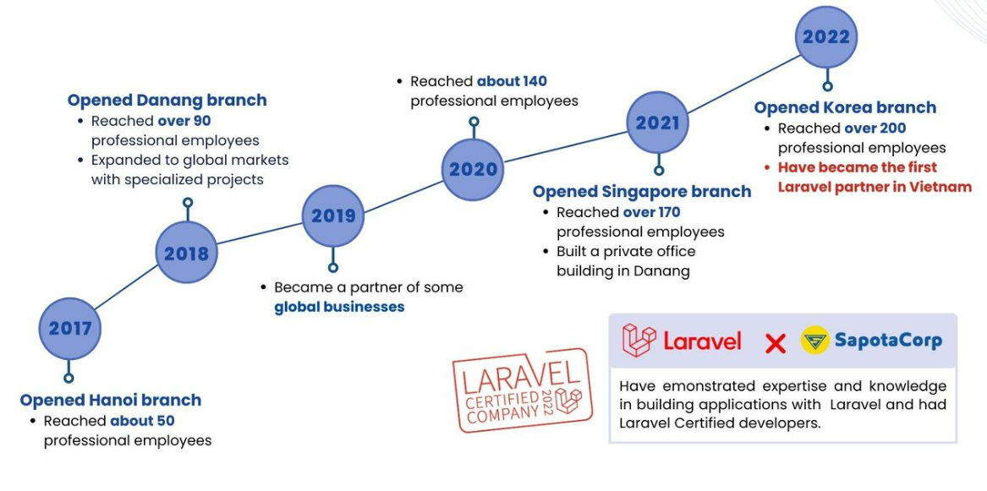

Image 1.1 Visual image of important milestone of Sapotacorp.

1.3 SapotaCorp company's mission and values.

1. Offering businesses the most innovative, cutting-edge website & software solutions.
2. Aiming to train our team to develop a variety of skills for comprehensive research & work.
3. Striving to assemble a team of exceptional individuals who excel in the niche they pursue to produce the best combinations of services.
4. Innovating constantly, creating outstanding technology solutions to serve the global market & contribute to humanity.

- Technologies are being used by company.

2.1 Technologies used in company.
2.1.1 Framwork.
- Laravel.
- Flutter.
-

Explanation of how these technologies are applied in the company
Importance of these technologies for the company

- Training plan and projects

3.1 Training plan.

PRIMARY DESCRIPTION | EXPECTATION  /OUTCOME | LEVEL | SUPERVISOR | SCHEDULE
Learn Web API Development using Nodejs | - Learn about JavaScript syntax, variables, data types, conditions, loops, and functions.  - Become familiar with concepts like arrays, objects, and JSON in JavaScript.  - Practice writing simple JavaScript code to get familiar with the language.  https://www.youtube.com/watch?v=0SJE9dYdpps&list=PL_-VfJajZj0VgpFpEVFzS5Z-lkXtBe-x5 | From intermediate to advance | Phạm Công Quốc Hùng | Week 1
Learn Web API Development using Nodejs | Week 2  - Download and install Node.js from the official website (https://nodejs.org).  - Check that Node.js and NPM versions have been successfully installed by running the node -v and npm -v commands in a command line window.  https://youtu.be/7sX_8lKURqo | From intermediate to advance | Phạm Công Quốc Hùng | Week 2
Learn Web API Development using Nodejs | - Practice and build real applications  - Learn about the Express.js framework and how it simplifies building web apps with Node.js.  - Learn about routing, middleware, template engine, and other concepts in Express.js.  - Build simple web applications using Express.js to apply what you’ve learned.  https://youtu.be/z2f7RHgvddc?list=PL_-VfJajZj0VatBpaXkEHK_UPHL7dW6I3 - Learn about databases like MongoDB or MySQL and how to connect and interact with them in Node.js.  - Learn an ORM (Object-Relational Mapping) like Mongoose or Sequelize to interact with the database easily and flexibly.  https://youtu.be/UxiTsvUuYFA?list=PLIGDNOJWiL1-eFfnY4bAyCI8bsIOHmNtE | From intermediate to advance | Phạm Công Quốc Hùng | Week 3-4-5-6
Final Real Project | Join company’s projects |  | Phạm Công Quốc Hùng | Week 7-8

Details of the training plan
Overview of the projects undertaken during the internship
Learning outcomes and skills gained during the projects and training plan

- Achievement
Summary of the achievements made during the internship
Explanation of the impact of these achievements on your improvement and skills
- Evaluation from PNV’s mentor
……………………………………………………………………………………………
……………………………………………………………………………………………
……………………………………………………………………………………………
……………………………………………………………………………………………
……………………………………………………………………………………………
……………………………………………………………………………………………
……………………………………………………………………………………………
……………………………………………………………………………………………
……………………………………………………………………………………………
……………………………………………………………………………………………
……………………………………………………………………………………………
……………………………………………………………………………………………
……………………………………………………………………………………………
……………………………………………………………………………………………
……………………………………………………………………………………………
……………………………………………………………………………………………
……………………………………………………………………………………………
……………………………………………………………………………………………
……………………………………………………………………………………………
……………………………………………………………………………………………
……………………………………………………………………………………………
……………………………………………………………………………………………
……………………………………………………………………………………………
……………………………………………………………………………………………
……………………………………………………………………………………………
……………………………………………………………………………………………
- Evaluation from Company’s supervisor
The evaluation will be attached in the report

